### Burton School

Burton, NB

May 2018

**V**

**Jump Rope for Heart**

School News

May 2018



Did You Know?

We have set some tentative dates for June that people might like to know about in advance. Please note these dates are subject to change.

June 15th- Family Picnic- all families will be invited to come to the school for a school picnic beginning at 11:00 am.

June 18th- Field Trip- Oromocto Ceramics and Oromocto Fire Station tour AM/ picnic and outdoor events at school in PM

June 22- last day for students.

Student Recognition

Congratulations to the following students who were recognized during March’s and April’s assembly for their “bucket filling” behaviour:

**March**

Kindergarten: Guinevere Smith

Grade 1: Evie Yates

Grade 2: Maggie Alexander

Phys Ed: Sierra Dessouroux, Zoey Sever, Collin McIntyre

Principal’s Choice: Victoria Morrissey

**April**

Kindergarten: Honour Livingstone

Grade 1: Victoria Morrissey

Grade 2: Tyson Levi

Phys Ed: Ella Peori, Emily Gauthier, Caitlin Wyllie

Principal’s Choice: Joshua Alexander

For May’s assembly, we will be having a presentation by kindergarten. The assembly will be held on **Friday, June 1st at 11:15 pm** in the gym.

Our theme for May will be “hard worker”.

Plastic Bag Recycling Challenge

Our school has entered a challenge to recycle as many plastic bags as we can by June 2, 2017. We will be counting the bags and taking a fun picture at the end of the contest before I take them to Walmart for recycling. The school that collects the most bags per student will be eligible be win a cash prize. Start collecting and show your child the importance of the 3 R’s!

Dates of Interest

May 4- Provincial Council Day- **NO SCHOOL FOR**

**STUDENTS**

May 9- Jump Rope for Heart Campaign begins

May 11- Jump Rope for Heart activities

May 14 - NBTA Branch Meeting- **NO SCHOOL FOR**

**STUDENTS**

May 18- Jump Rope for Heart forms due

May 21 - Victoria Day – **No school**

May 22- Grade 2 provincial reading assessment begins

May 25- 1:00-2:00 pm- kindergarten orientation for those coming to kindergarten next year

May 28- Home and School meeting 6:00 pm/ PSSC- 7:00 pm

May 29- Professional Learning for teachers- no school for students in PM (dismissed at 11:15 am)

June 1- Recognition Ceremony 11:15 am

# Jump Rope for Heart

On May 9th we will kick off our Jump Rope for Heart campaign by speaking about the importance of the heart as well as describing the fundraiser that will be taking place. On May 11th we will be having our own event with students participating in several skipping activities. Collection forms will be sent home in May and the due date for the collection of the forms will be May 18th.



**r Heart**

**Pun**

# Kindergarten

**Literacy**

* Students will continue to work on sight word recognition and using the reading strategies that have been taught to attempt to decode unknown words. Students should be using the reading strategies “lips the fish” (look at the first letter of a word) and “stretchy snake” (sound it out).
* Students are working hard on their books during writing time! They are being encouraged to read their book when they are done in order to check for spaces, punctuation, and to ensure that their words make sense.

**Numeracy**

* We will be completing our measurement unit this month
* We will be revisiting patterns and number concepts.

**You and Your World**

#### We will be learning about safety in the home, school, and community

#### Grade One

**Literacy**

* In Writing, we have been working on book making. (See principals corner for a further explanation). We will continue with our personal writing goals, which are mainly in the area of conventions.
* In reading, we will continue to work on reading strategies, sight words and word families. We will also be continuing our vocabulary development. Some words we have covered so far are: blame, tremendous, disguise, gasped, flung, mysterious, lonely, apologize and crept/creeping.

**Numeracy:**

* Addition and Subtraction to 18
* Mental math strategies for addition/subtraction to 18
* Revisit estimation to 20

**You and Your World:**

* Environment, , At My Best ( nutritional eating, mental and physical wellness)

#### 

#### Grade Two

**Literacy**

❖  Daily Five and Café

❖  Concepts / Vocabulary: comprehension, fluency, expression, strategies

❖  Writing

❖  Concepts / Vocabulary: punctuation, spacing, million dollar words, details, lengthening of stories

❖  Provincial Assessment at end of month (May 22 – June 1)

**Numeracy**

❖  Revisit Measurement

❖  Concepts / Vocabulary: measure, length, height, mass, heavy, light

**You and Your World**

####    Mother’s Day, Air and Water

**Principal’s Corner**

Last month if you were able to attend the recognition ceremony, you would have been witness to the books students are writing in class. The idea sprang from a workshop Mrs. Wells attended in the winter and brought back to school. In looking at the book they had used for the workshop, About the Authors, and asking our district literacy mentor for support, we explored using books as a means of teaching writing skills. The students loved this concept! They were so excited to become authors and their enthusiasm for writing increased dramatically. Students looked at different authors and modelled their books on some of the ones they had read using their own areas of expertise to create books. Teachers then confer with the students to develop their writing skills according to their individual needs. We are excited to see the engagement of students in their writing and will continue to explore using this strategy.

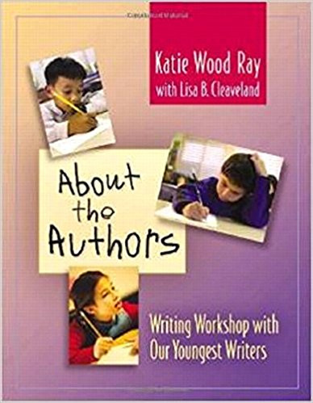

Burton School Newsletter Page 2